Angular – HTTP GET Request (SELECT)

In HyperText Transfer Protocol or HTTP protocol, the clients a process of starting communication with the server by the client application or browser. In Angular, a request refers to making HTTP calls to a server to fetch, send, or manipulate data. These requests are handled by the Angular HttpClient module.

The following diagram will give you a clear understanding of the HTTP Request:
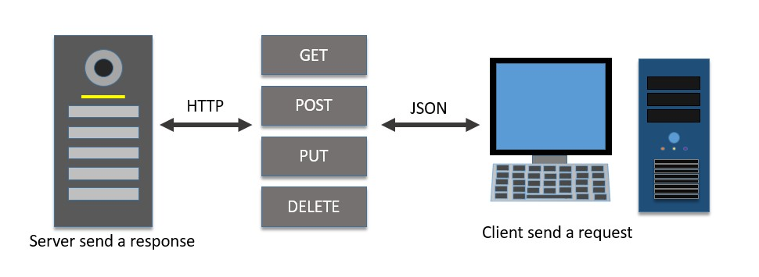
The HTTP standard verb GET can be used in HTTP protocol to get (retrieve) a resource (data) from the server. The purpose of theGET method is to request data from the server. The server will check for the specified resource in the server and send it back if it is available.
In Angular, the HttpClient service class provides a get() method to request data from the server using the HTTP GET verb. Let's learn more about this method, including it's signature, parameters, and real-time usage:

Signature of the get() Method
Following is the signature (different from syntax) of the HttpClient get() method
Here,
- url − The URL to which the GET request is sent.
- options − represents the options to be send along with the resource URL.
- Observable<T> − The return type, where 'T' represents the expected response type.
To work out the HTTP client-server communication, we need to set up a web application and need to exposes a set of web API. The web API can be requested from the client. Let us create a sample server application, Expense API App, and provide CRUD REST API (mainly GET requests) for expenses.
Note: Refer to guide how to Create a Server for Expense REST API. The server must be running while testing this client application.
Let us create a working angular example to get all expense items from the above server application by using the HttpClient service class and get() method.
- Create a new Angular application app-http-request, and open it with VS Code:
- We need to import the HttpClient in App Config file (app.config.ts)
import { ApplicationConfig, provideBrowserGlobalErrorListeners } from '@angular/core';
import { provideRouter } from '@angular/router';

import { routes } from './app.routes';
import { provideHttpClient, withInterceptorsFromDi } from '@angular/common/http';

export const appConfig: ApplicationConfig = {
providers: [
provideBrowserGlobalErrorListeners(),
provideRouter(routes),
provideHttpClient(withInterceptorsFromDi())
]
};
- Create a new interface, Expense to show the expense items from the server
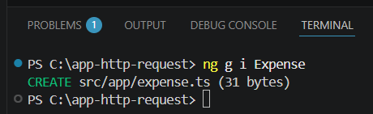
- In the Expense interface file (expense.ts), prepare the code
interface Expense {
id: Number,
item: String,
amount: Number,
category: String,
location: String,
spendOn: Date
}
export default Expense;
- Create a new component, ListExpenses to show the expense items from the server
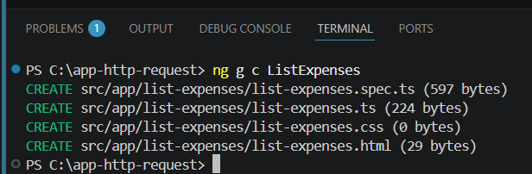
- In app.ts
import { Component, signal } from '@angular/core';
import { RouterOutlet } from '@angular/router';
import { ListExpenses } from "./list-expenses/list-expenses";
@Component({
selector: 'app-root',
imports: [RouterOutlet, ListExpenses],
templateUrl: './app.html',
styleUrl: './app.css'
})
export class App {
protected readonly title = signal('app-http-request');
}
- In app.html, add the selector
<app-list-expenses></app-list-expenses>

<router-outlet />
- In file list-expenses.ts, do the following Tsks:
  - inject the HttpClient into the ListExpenses component
  - Implement the OnInit life cycle hook to request the server for expenses after the initialization of the ListExpenses component
  - Create a local variable, expenses to hold our expenses from the server
  - Call the get method of this.http (HttpClient instance) object by passing the URL and options to get the expense object from the server. Then, set the expenses into our local variable, expenses
The complete code is as listed below:
import { Component, OnInit } from '@angular/core';
import { HttpClient, HttpRequest, HttpResponse, HttpEvent } from '@angular/common/http';
import { DatePipe } from '@angular/common';

import Expense from '../expense';

@Component({
selector: 'app-list-expenses',
imports:[ DatePipe],
templateUrl: './list-expenses.html',
styleUrls: ['./list-expenses.css']
})
export class ListExpenses implements OnInit {
expenses: Expense[] = [];
constructor(private http: HttpClient) { }
ngOnInit(): void {
this.http.get<Expense[]>('http://localhost:8000/api/expense', {
'observe': 'body',
'responseType': 'json'
})
.subscribe( data => {
this.expenses = data as Expense[]
console.log(this.expenses)
})
}
}
- Next, get the expenses object from the component and render it in our component template page (list-expenses.html)
<div><h3>Expenses</h3></div>
<ul>
@for(ex of expenses; track $index){
<li>
{{ex.item}} @ {{ex.location}} for {{ex.amount}} USD on {{ex.spendOn | date:'short' }}
</li>
}
</ul>
- Save all files
- Make sure that the Express RestAPI server is up and running . Run the application.

